**7 Segment Code :**

#include <reg51.h>

void delay (int k);

void main()

{

unsigned char i;

unsigned char arr[10] = {0x3f, oxo6, oxsB Ox4F, OX66, 0x6D, Ox7D, 0x07, Ox7F, 0x67};

P0 = 0x00;

while (1)

{

for (i=0;i<10;i++)

{

P0 = arr[i];

delay(100);

}

}

}

void delay (int k)

{

int i, j;

for (i=0; i<k; i++)

for (j=0; j<1275; j++);

}

**Interfacing Diagram:**

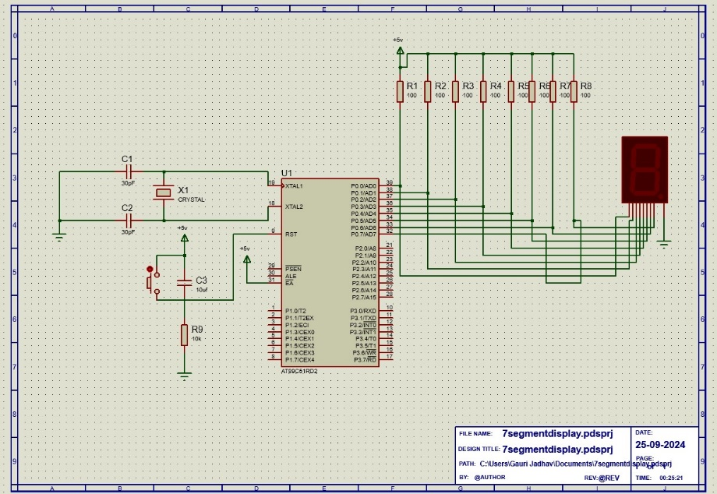

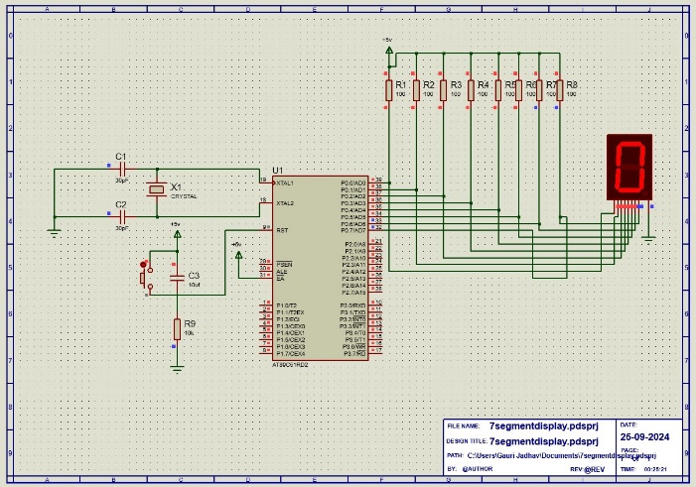**Output :**

